Lab – Password Cracking

1. Objectives

Use a password cracking tool to recover a user’s password.

1. Background / Scenario

There are four user accounts, Alice, Bob, Eve, and Eric, on a Linux system. You will recover these passwords using John the Ripper, an open source password cracking tool.

1. Required Resources

* PC with Ubuntu 16.04 Desktop LTS installed in a VirtualBox or VMware virtual machine.
  1. Open a terminal window in Ubuntu.
     1. Log in to Ubuntu using the following credentials:

User: **cisco**

Password: **password**

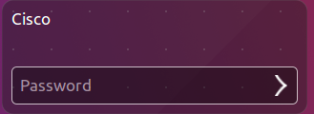

* + 1. Click on the terminal icon to open terminal.



* 1. Run John the Ripper.
     1. At the command prompt, enter the following command to change to the directory where John the Ripper is located:

cisco@ubuntu:~$ **cd ~/Downloads/john-1.8.0/run**

* + 1. At the command prompt, enter the following command :

cisco@ubuntu:~/Downloads/john-1.8.0/run$ **sudo ./unshadow /etc/passwd /etc/shadow > mypasswd**



This command will combine the /etc/passwd file where user accounts are stored, with the /etc/shadow file where user passwords are stored, into a new file called “mypasswd”.

* 1. Recover Passwords.
     1. Type the following command in terminal:

cisco@ubuntu:~/Downloads/john-1.8.0/run$ **./john --show mypasswd**



As shown above, there are no cracked passwords at this point.

* + 1. At the command prompt, enter the following command:

cisco@ubuntu:~/Downloads/john-1.8.0/run$ **./john --wordlist=password.lst --rules mypasswd --format=crypt**



The program, John the Ripper, uses a predefined dictionary called **password.lst** with a standard set of predefined “rules” for handling the dictionary and retrieves all password hashes of both md5crypt and crypt type.

The results below display the passwords for each account.

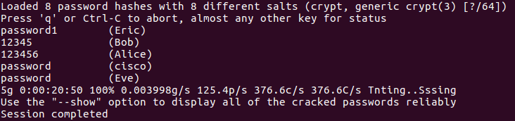

* + 1. At the command prompt, enter the following command:

cisco@ubuntu:~/Downloads/john-1.8.0/run$ **./john --show mypasswd**

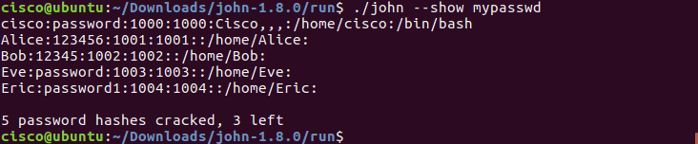

How many passwords were cracked?

____________________________________________________________________________________

**References**

John the Ripper: <http://www.openwall.com/john/>